Annex 4
True stories of 'characters'
ARMANI, AFGANISTAN
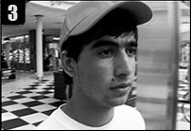

Armani is seventeen years old and says that he doesn’t have any dreams. He left his family in Afghanistan. His father worked for an American civilian. He refused the Taliban when they demanded him to lead them to his workplace so that they could kill his employer. He died blown up by an explosive that someone had thrown into his car. According to the Taliban, the burden of betrayal was taken over by his oldest son, Armani. The teenager tells us that he had to leave the country, even though he did not want to. The most important thing for him is to see his mother, though it is impossible. “She tells me: don’t think about Afghanistan, think about the future. But what future do I have? What’s most important is the future of my country. Without bombs being dropped by the Americans”.
At the beginning of 2011, three ISAF soldiers died in Afghanistan and a terrorist detonated an explosive in a bath house in Spin-Boldak, a town at the Afghan-Pakistan border. Although the aim was a border patrol official, 20 civilians also died. Over the last few years, the citizens of Afghanistan have not stopped abandoning their home country. At the beginning, they tried to start a new life in the neighbouring countries. However now, Iran and Turkey especially, don’t want any more Afghan refugees. The Afghanis stopped at the border are deported.
At the beginning of the 21st century, over three and a half million Afghani refugees resided in Pakistan and Iran. Now the only option for the majority of refugees is Europe, where the potential new citizens are not really welcome.
Source: http://www.politykaglobalna.pl/2011/01/historie-uchodzcow-z-afganistanu/

César Millán, Mexico



Cesar grew up on a farm in a cramped, four-room clay house that had no running water. He used to help his grandfather graze a dozen cows, but had always dreamed of becoming a star. On the eve of Christmas, he left with all his father's savings ($ 100). He neither had a passport nor did he realize how difficult it would be to cross the border. Finally, after several failed attempts to force the fence, when he was repeatedly caught by the border patrol, the young Mexican, born in Culiacán, Sinaloa, illegally crossed the US border following the Tijuana trail. But before that happened, the police stopped him many times and threatened to deport him to Guatemala.
At that time of year, it often rained heavily, with the water flooding large areas and destroying many homes. One day, in the days before his successful crossing, as part of a larger group, he was following a smuggler who led them along something akin to a canal as the rain grew heavier and heavier. Suddenly the water current hit them with such a force that it took some of them away. "I saw it take pregnant women and old men, but the smuggler responded to it by merely saying, ‘Keep following me’. He did not care a bit about the death of those people and the crying of their families," he recalls.
After two weeks, César spotted his chance: a freshly made hole in the fence. Out of the blue, a man appeared. "He came up to me and asked: ‘What? You wanna go through?’ I replied I did and so he charged me 100 dollars for it – the exact money I had in my pocket ", Cesar recounts the story. He recalls the border of the state: the two men crossed the highway, and then they kept running against the traffic down the side of the wal. At last, he followed the guide into a tunnel. His mind was coursing with the fear that the smuggler would kill him now, but at the end of the tunnel the man told Cesar to wait, then he whistled, and, after a while, signalled towards an approaching taxi. When the cab came up to them, he just shoved Cesar into it.

When Cesar arrived in San Diego, he was relieved not to have to run any more; now all he had to do was hide. It was existentially important to find out where people like him found shelter. He discovered that many are hidden under motorways and decided that was where he would hide too. He found a cardboard box and set out on a search for a home. César spent two months under a San Diego motorway. During that time, he worked on a dishwasher and took on any work that allowed him to survive.

After two months, he saved enough money to reach the place that was his true goal: Los Angeles. He found a job at a kennel and later began walking dogs – even for free. "I was walking 5 dogs, then 10, then 15, until I got to be known as the Mexican who can take the whole pack of dogs for a walk," he says.

After some time, the Los Angeles Daily published a photo of César walking a horde of canines. When asked by the reporter what he wished for, he replied that he would really love to have his own program on television. After the article was published, a host of TV producers were willing to offer him a contract. And that is how he came to run his own reality show called “Dog Whisperer”.

Source: CésarMillán: La historia w https://www.youtube.com/watch?v=AVFODvAvfM8

Daela, Emad, Sandra, Masa Dasuqi, Syria

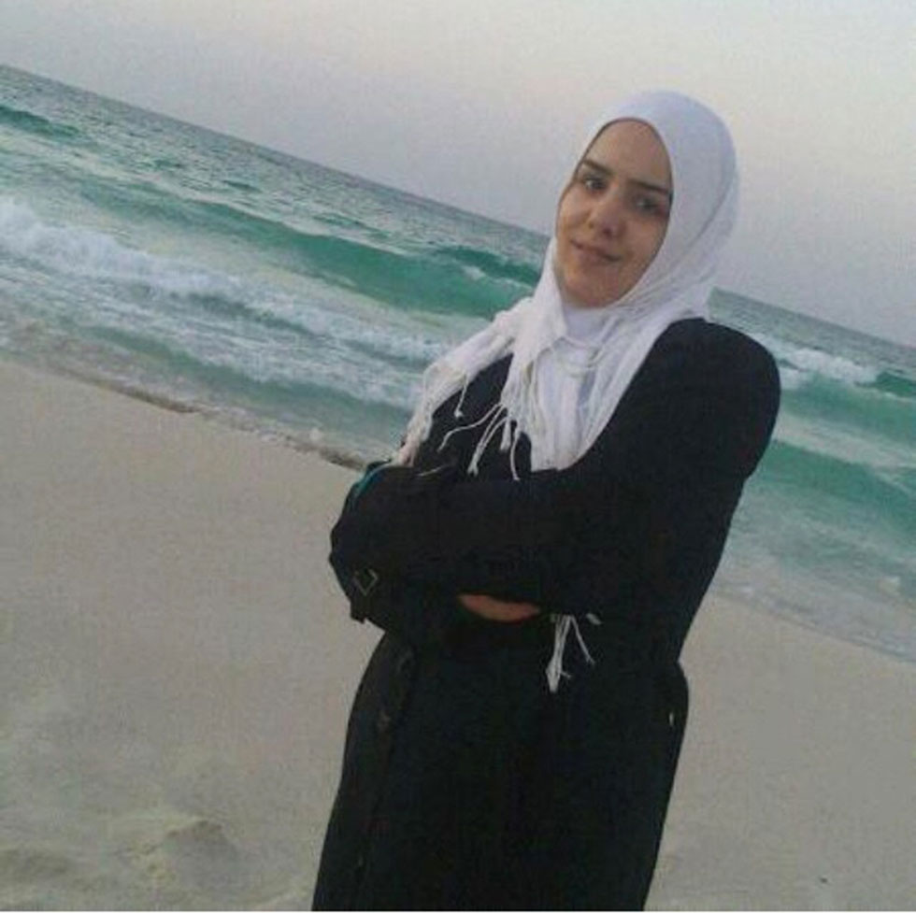
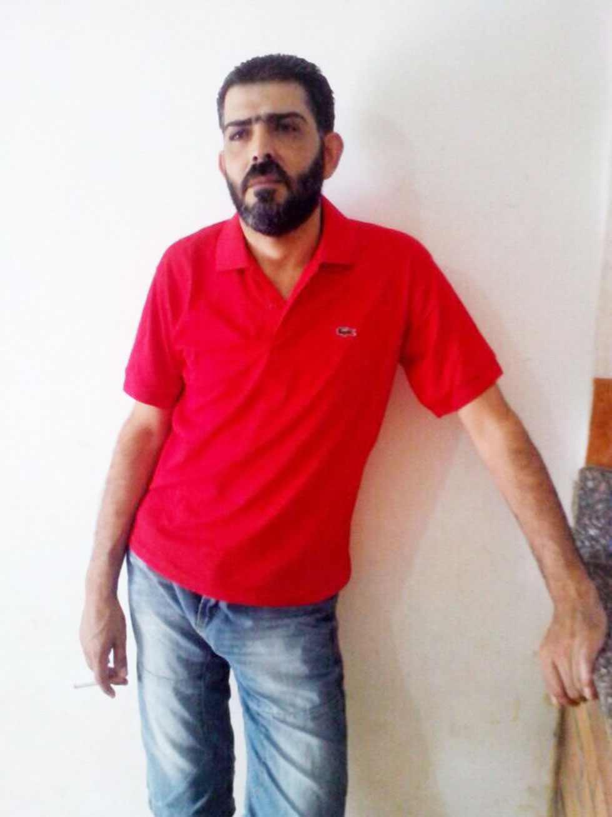

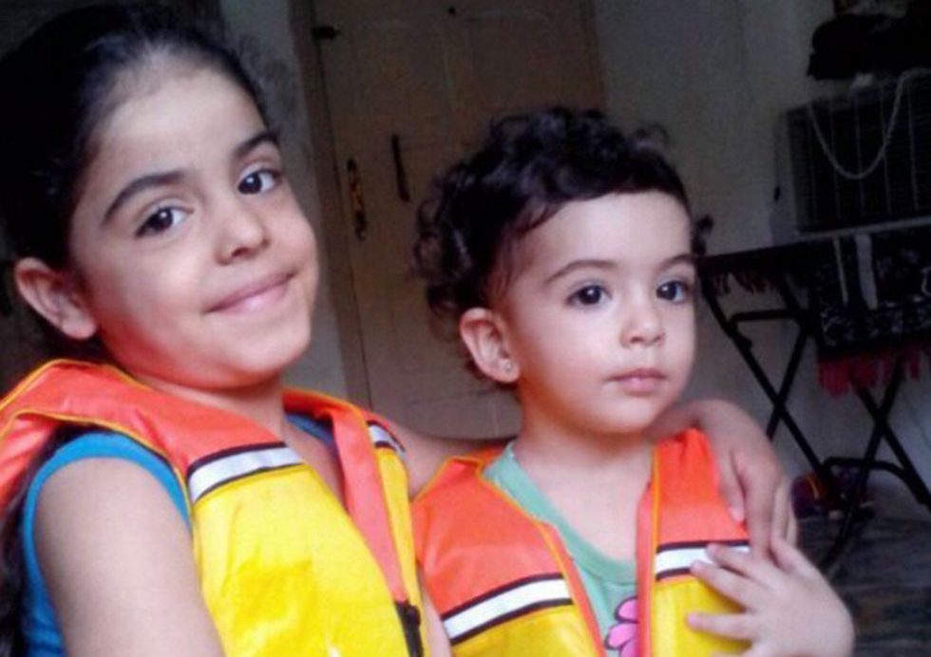
Masa was still in the mother's belly, Deala, when the Dasuqi family decided to leave their home in Syria in November 2012. The bloody fighting between Syrian and the opposition troops made life in Qaboun too dangerous to carry on living there and the family set out to find a more peaceful place in Syria's capital, Damascus.
Six months after reaching the Syrian capital, when Massa was only four months old, the family boarded a plane to take them to Cairo, the capital of Egypt. Over time, they found themselves in the coastal city of Alexandria.

In September 2014, Massa and her second sister Sandra, along with their parents, Emad and Deala began a journey to Europe. Prior to it, while staying in Egypt, they tried to arrange a visit at the Embassy of Sweden in Egypt to claim a family reunion with Sidra, one of the daughters who had earlier emigrated to the Scandinavian country with her uncle. But months passed without any breakthrough and the family, who could no longer bear the hardships of life and separation from Sidra, decided to take their destiny into their own hands.
On September 6, a ship set sail for the Egyptian port city of Damietta, aiming to eventually reach Italy – the Dasuqi family were on board of the vessel. Most of the passengers were women and children from Syria and Palestine. However, the ship never reached its destination. About 5 miles from Malta they were approached by a smaller ship, whose crew attempted to forcefully take them, over 500 refugees, onboard . People were resisting and suddenly, according to the survivors, the little boat foundered and began to sink rapidly.

One of the passengers, a nineteen-year-old Doaa al-Zamel remained afloat thanks to the lifebuoy she had been given by her finace. Deala was extremely weak – she felt she had no more fight left in her. Spotting the nineteen-year-old girl, Deala swam up to her and, and, before she succumbed to the battle for life, she gave Doaa her baby and asked her to take care of her child. Her husband and daughter, Sandra, also failed to survive. On the fourth day of drifting on the water, Doaa and Masa were rescued by a Greek helicopter and taken to hospital. Later Masa was taken to the orphanage of the Miter Foundation, near Athens.

Masa’s uncle, Mohammed Dasiqi, learned about the ship’s catastrophe from Facebook and the very next day flew in to Crete to see his niece. Thus his long battle with the Greek bureaucracy, which did not want to give him the baby, began. He had to travel several times between Sweden and Greece to prove his blood relation with Masa, among other things, to perform a DNA test. Finally, on 6 April 2015, the court in Chani issued a long-awaited verdict: he entrusted Mohammed with the care of Masa. Two months later Masa received a Swedish right of residence and after nine months she was able to leave the orphanage. For now, she only speaks Greek and is forgetting Arabic. To help Masa adapt to her new life in Sweden, a Greek friend of the family, Francesca Koomen, remains with her in Göteborg. Francesca has been involved with the case since the very beginning.
Mohammad's wife is 23 years old; he is two years older. "We do everything possible to give girls (Sidra and Masa) the best possible life. Luckily, we have many relatives here who help us”, says the woman. Young spouses are temporary caregivers, but the social services investigate the family's ability to provide constant childcare.

Source: Masa w http://blogg.gp.se/reportage/2015/07/24/masa/

Màrtine Samba, Democratic Republic of Congo
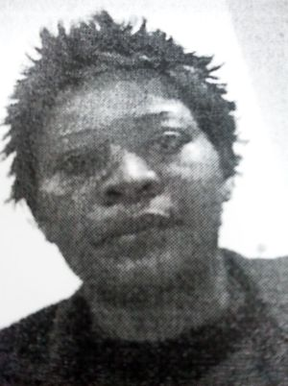

Samba Martine was born in Democratic Republic of Congo. She left the country with 9 year old daughter, Bijoux, to go to France. After a long, exhausting journey through half of the African continent they managed to get to Melilla, Spain in August 2011. Upon the arrival Martine was locked up in CETI (Centre of Temporary Stay of Immigrants). She was also separated from her daughter who was sent to France to meet the family relatives while her mother was kept in a detention centre for three months, till November 2011. At that time, due to overcrowding in CETI she got transferred to CIE (Centre of Immigrant Detention) in Madrid to be deported. However, Samba insisted that the reason she’s staying in this town is a political situation of Democratic Republic of Congo due to which she is planning to apply for asylum in Spain.
During 38 days spent in CIE Samba needed medical help at least ten times but she never got properly diagnosed. She didn’t speak Spanish and it seems that no interpreter was present during the doctor’s appointments. Several women who lived with her in the arrest said that her physical weakness was clear and obvious. Sometimes they had to help her get to the room because she couldn’t do it on her own. On Monday 19th of December she had been sent to Doce de Octubre hospital where she died a few hours later. Her family never received a slightest explanation about the circumstances surrounding her death nor did they hear any word of sympathy from the people responsible for the arrest.
The autopsy showed that Samba had been carrying HIV. From a technical point of view, according to the forensic medicine report, she died due to cryptococcal disease – a virus that can be fought by a healthy person but can turn out lethal in someone with untreated immune deficiency, which had been Martine’s case.

Source: Entrevista a Juan Diego Botto. Exilio e Inmigración (historia de Samba Martine) w https://www.youtube.com/watch?v=E0kL26qk_SI

Bertín Youmssi, Cameroon

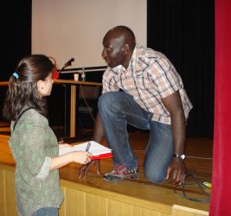

Bertín left his house at night without saying goodbye to anyone. He didn’t want to see his mother’s tears. He couldn’t bear to spend another New Year’s Eve not being able to feed his sister and brother. His country, Cameroon, offered no possibility of growth.
His journey lasted two years. He travelled during the night so that the police would not catch him and force him to return. His aim: Morocco’s border in the high mountains. He climbed up, marching night after night and sleeping through the days in hiding. Below, in a valley, he saw a dazzling carpet. It was Ceuta. Europe. It was paradise.
However, there was a triple electric fence that stretched out between the paradise and reality. It took Bertín one and a half years to save the 1,300 euros necessary to cross the border. He took any job. He saved every penny. Until he met people who offered to swim through the Strait with him on their back. The “carriers” put on neoprene wetsuits. An illegal immigrant holds on to their backs and they set off into the sea like a giant turtle. They were stopped by police as they were crossing the water. He spent three months in an assistance centre in Ceuta. They took him to a hearing against carriers. He had to testify. He applied for political asylum. He got rejected. He got a ticket to Navarra and a document that enabled him a stay of 6 months and then he was required to return to Cameroon.
He left Navarra to go to Madrid, where he achieved a lot over the course of two years. He found a group of friends with whom he could integrate and began studying at University. He helps illegal immigrants to legalise their stay in Spain.
He passed the university entry exams for people over 25 years of age with a distinction. He is going to start studying Law in the next academic year. He thinks of his return to Cameroon with fear:
“Those who study in Europe and return to Cameroon get good jobs in administration. The average life expectancy in Cameroon is 35 years old. I am 32. When I go back, how many of my friends will already be dead?”

Source:http://noticias.universia.es/ciencia-nn-tt/noticia/2007/08/01/591258/inmigrante-africano-cuenta-experiencia-resultados-viaje-mundo-opulencia.html

Omar Alshafai, Syria

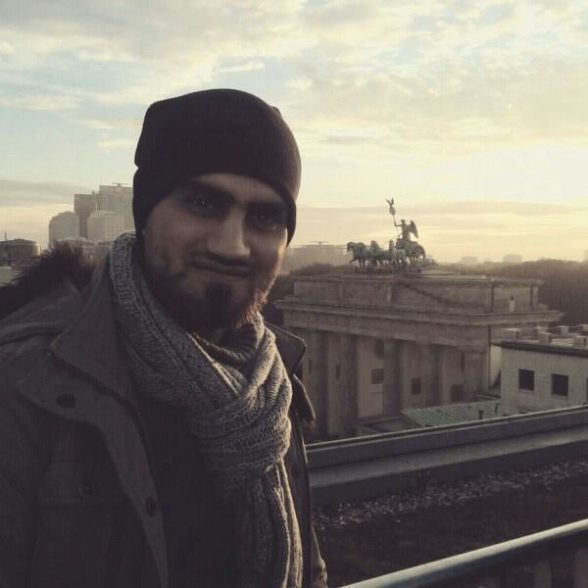

His family is large, living all over Syria, with some members also having emigrated abroad. Prior to the Arab Spring, he worked for eight years in Saudi Arabia, as a company manager. Before that stint, he served two years in the Syrian army. In 2011, when the revolution broke out, the situation in Syria was not very dangerous yet, but Omar decided to return to Damascus to look after his family. He opened a computer shop there, had a fiancé and planned to get married.

Initially peaceful demonstrations soon descended into war. The situation became increasingly dangerous. One day, just like all young men, he got a military draft notice letter to join the government army. That meant shooting and killing other Syrians - neighbors, friends, friends. It also meant, as far as he was concerned, a certain death. The family wanted to protect him and so they decided to send him to Lebanon. After five days there, he realized there was no chance of finding a job and a normal life in Lebanon. He took a decision to sell his home and computer shop, for which he got some 5,000 dollars, and set off for Europe. He bought a plane ticket to Algeria and soon landed in the capital of the country. He spent there a week, during which time he contacted smugglers who organized refugees' journey to Europe. Thus another plane took Omar to a town near the border with Tunisia. "We were transported in a pickup truck to the border and then crossed it on foot. The Tunisian police stopped us several times, but allowed us to carry on even though we had no travel documents. On the Libyan side of the border, another smuggler's car took us to the seaside city of Zuara. We came under fire several times – the country isn't safe either. But it's only owing to the war that refugees can find a boat to Europe in Libya”.

After several days of waiting, he was taken to the beach where a boat was waiting. As many as 450 people, including women with children and elderly people boarded the boat. Water and food supplies aboard were insufficient. They did not have a captain and no one who knew the route. Still, after two days, they managed to reach Sicily in Italy. They were immediately approached by the police – Omar was forcefully taken to a place where he had his fingerprints taken. He planned now to get to Denmark, where his brother lived. He managed to reach his destination via Germany, where he was fingerprinted for the second time. After eight months in Denmark, he was informed that he would be sent back to Italy under the so called Dublin II regulations. "I did not want to go back there because Italy cannot handle the number of refugees it receives and it is nearly impossible to find a job or start a new life there." The Danes had already bought him an air ticket to Italy but he informed the authorities that he wanted to say goodbye to his family in Germany and went to Berlin again. Germany issued him a residence permit for three years. He began to learn German, attended two additional programming courses and completed an internship programme. During that time, he created the Bureaucrazy application, which helps refugees to navigate asylum procedures in Germany. Omar has been interviewed by Siemens and hopes to start working there next year.
"If I were in Syria now and had to decide again, I think I would prefer to stay and die rather than go through all the hardships again," he concludes.

Salwa Yussef, Syria

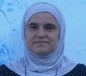

Salwa Yussef is running a library for refugee children in Nizip – a small town located not far away from the border with Syria. The library is financed by Turkey and UNICEF donated 400 books in Arabic, mostly fairy tales.
“Before the war I used to write short stories. In one of them, a young woman gets banished from home because of the war. I describe her struggle, how she gets used to the new situation. I would’ve never thought it will become a story of my own life.
I am a Cherkess, like many here (before the war there used to be a Cherkess diaspora in Syria). I come from the mountains near the border with Jordan and Israel. We ran away when the soldiers started to recruit local youth to the army. I have three sons – the oldest is 21 years old, the youngest is 14.
I would like to go back to Syria but as long as Assad remains in power – it’s not possible. Europe only sees what it wants to see. I am afraid it will help Assad. Syrians don’t deserve that. We are not terrorists, we love peace. We are hard workers. I don’t know how can I change your opinion about us. What would you do if someone stormed into your house and started to destroy it?”

Source:http://wyborcza.pl/1,75399,19254097,listy-uchodzcow-do-europy-trzy-historie-trzy-kobiety-kazda.html

Waris Dirie, Somalia

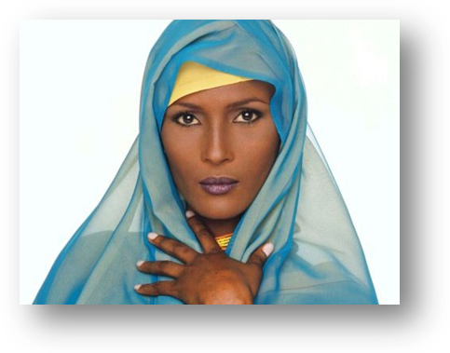

Waris was raised in Daarood, Somalia. Her family were nomadic shepherds of livestock. They lived in a grass hut they had moved from one place to another on the back of a camel every few weeks to find new pastures for their herd. As early as at the age of six she already worked and overlooked a herd of about 60 sheep and goats as they grazed in the wilderness of the desert. By Somali standards, the Dirie family were well-off.

When she was about thirteen years old, her father announced to the whole family that he had found a husband for her – a 60-year-old man, who bought her for the price of five camels. Unwilling to marry him, which would result in raising children in an isolated settlement in the desert, Waris fled home. She headed for the Somali desert, without a clear idea where she would go. Nine days later she arrived in Mogadishu, where she located some relatives. Later she found employment as a bricklayer. When she learned that one of her uncles was appointed Somali ambassador to the United Kingdom and suggested that she could work as a maid for his family, without thinking twice, she grabbed the opportunity and came to London, where, for the first time in her life, she saw snow, toilets and escalators. But when the family suggested returning to Somalia, she hid her passport and became an illegal immigrant. She found a kitchen porter job at McDonald's. After a few months she started studying on evening courses, where she learned English

In 1997, she published her book Desert Flower: An Unusual Deserted Travel, co-written with Cathleen Miller. Soon after, she became a spokeswoman for the United Nations campaign against circumcision of women and abandoned her modelling career that she had taken up in the UK. Waris is now the special ambassador for women's rights in Africa.

Source: Waris Dirie Biography w http://biography.jrank.org/pages/2958/Dirie-Waris.html oraz https://en.wikipedia.org/wiki/Waris_Dirie

Amar, Rolanda, Yasmin Obaid, Syria

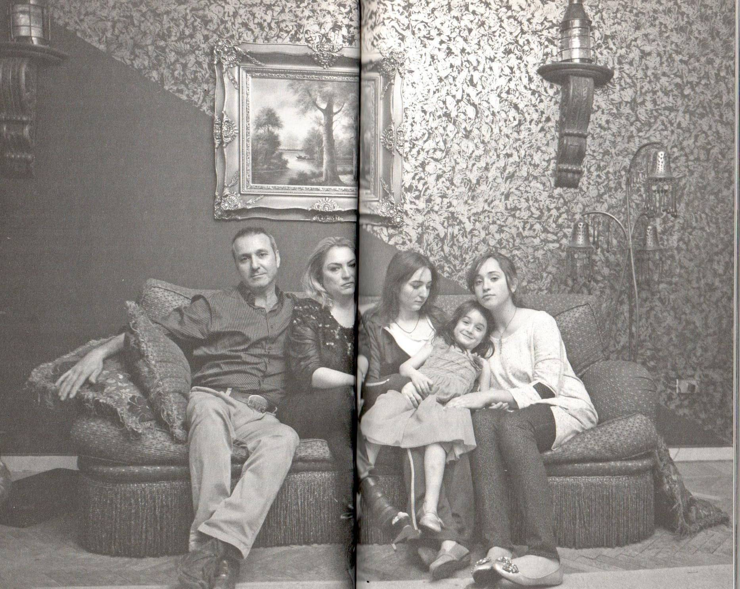

The family comes from a Syrian city of Hons and for generations has belonged to the merchant class and big land-owners. After the revolution broke out in 2011, Amar, his wife and their 3 daughters fled to Egypt. He had savings and opened a small import firm in Egypt, he imported furniture from India and Bali. He opened a shop, employed up to eight salesmen, travelled frequently. However, after the revolution, the government’s attitude towards refugees changed. The junta imposed visas. Amar could not leave the country to go on business trips. He was afraid he wasn’t going to get an entry permit. The media, politicians and the Egyptian citizens began to boycott Syrian shops, insults became more persistent and the hatred towards refugees grew. Thus, Egypt turned out to be a trap: returning to Syria was as impossible as a future in Egypt. Together with the family, they decided they would attempt another flight. This time to Germany. Unfortunately, you cannot do it legally, so Amar left first, leaving his wife and three daughters (the youngest being 5 years old and the oldest 17) in Cairo. The oldest daughter wants to study Psychology and asked his father to take her with him but, due to the fact she has not turned 18 yet, he refused. Amar, together with other refugees and smugglers, takes the coach to Alexandria, where they get locked in a rented apartment and wait for information regarding a ship that will take them to Europe. They spent days locked up in the apartment as they could only leave during the night, providing they had permission and were accompanied by a smuggler. After a couple of days, they received the information that the ship will arrive at night. The journey will take 6 days. Once they’re at the beach, they run towards the motorboats. It works on a first come, first served basis. The slowest ones will stay. The motorboats drop them off on an island. The smugglers do not explain anything that is happening. Moments later, the mother ship arrived and brought them on open sea. However, the journey did not last long as they were stopped by coast guards. They’re lying squashed together on the concrete floor. Amar spent a couple of weeks in jail. He had given his life jackets and water purifying tablets to the fellow passengers. The Syrian authorities deport him to Turkey. He tried to get from Istanbul to Rhodes, but was tricked by the smugglers. He buys a fake Turkish passport, but gets caught and turned back at the first border control. He takes a plane to Tanzania with a second fake passport, then takes a bus to Zambia and takes a plane to Frankfurt. The whole journey costs him another 3,000 EURO, that he received from his wife. Rolanda had to sell a diamond ring – a wedding present. After many months, he gets to Europe, where he ends up at a small refugee centre in a hessian city of Siegbach. He tries to get his wife and daughters to Europe. He is afraid that his family and marriage may not survive the long time apart.

Source: Bauer W., "Przez morze. Z Syryjczykami do Europy", Wołowiec 2016.

Ashna Rasheed, Irak

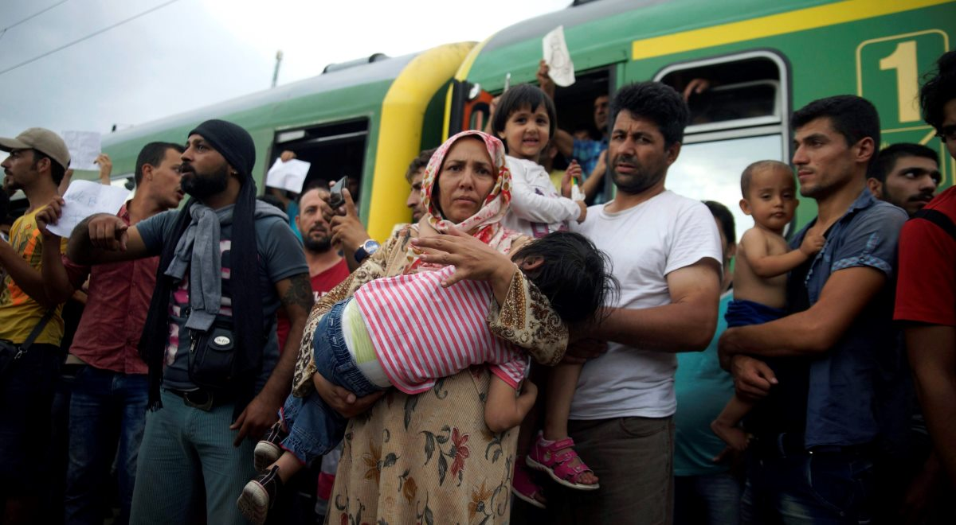

Ashna is a young Kurd. He used to live in the north-eastern district of Iraq, Tuz Khurmatu. He owned a grocery shop there. According to Ashna, he had to flee because he was afraid for his life. Last year he received a phone call informing him of the sentence he has been given.
The region that he comes from is at constant threat from the jihadists. A couple of months ago, many villages from the Tuz Khurmatu area have been released by the Iraqi army, but nobody is able to say if they are released permanently.
In 2007, Ashna’s uncle, an engineer working for one of the petrochemical companies, was kidnapped by people connected with the Al-Kaida. The terrorists demanded ransom from the family. They quickly collected the money, but his uncle still lost his life. They were able to capture the killers, who spent a couple of years locked up in an Iraqi prison. One of them was killed there. Now the others who were released are looking for revenge.
“They are people who previously worked for Saddam Hussain, then after the fall of his regime fought for Al-Kaida and are now part of the Islamic State” – the man says.
Ashna wanted to avoid the dangerous and expensive journey through the Mediterranean Sea. For months, the media has been reporting about thousands of casualties whose rented boats turned out to be too weak to get to the European coasts. He wanted to get a Czech visa. He decided it would be easier to get there. He gave an 800-dollar bribe to a smuggler who was supposed to help him, but it turned out that he needed an additional thousand and the outcome was not even certain. He decided to leave his passport and to not even ask about the money. He bought a fake ID and went to Turkey. Within a week, he linked up with smugglers who smuggled people over the sea. He got to Italy by boat and went to Belgium from there. “This whole journey cost me over 10,000 dollars. Was I afraid of crossing the sea? Of course, I was afraid” – the man recounts. Now the Kurd comes down to the plaza at Chaussee d’Anvers in Brussels, where the number of tents and people sleeping in them has now been growing for a week. He helps out, because he cannot work. He is waiting for a decision regarding his appeal.

Abu Hani i Yalda, Syria
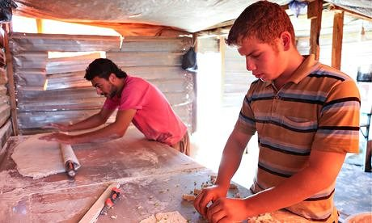

Abu Hani was the owner of a small supermarket in a Syrian town. When the war started, the officials who were destroying the town, added detergents to the wheat which he was using to bake bread in order to force him to close the shop. Hani spent all his savings to save the shop, which was then closed again. During that time you could see bodies of people getting murdered shown on the television. Oftentimes that was the only way for the family to identify the bodies of their loved ones. But usually people would just disappear. Three brothers of Yalda, Hani’s wife, were driving to the hospital to donate blood to their new-born nephew who went through a heart surgery. Those three men never made it to the hospital. They disappeared without any sing.
Hani and his family decided to go to Jordan. They didn’t want to bribe the immigration guards which ended up with Hani getting beaten up. The guards would kick him and jump on him for an hour and a half - his wife and children watching. They took all their money. Hani left the border in pain and with a brain concussion. He could barely move.
“We would wake up each day glad to be alive and go to sleep every night aware that we might not wake up in the morning. Our relatives were getting arrested, missing, murdered, died in the bomb explosions” – explains Yalda.
Hani borrowed money from his friends and once again travelled to the border with his family. This time he paid the guard who saluted them in return. They arrived at the Jordan border with empty pockets, worried about meeting the Jordan army but they greeted them with a smile and showed them the way to the refugee camp.
Hani works in the camp as a carrier. Because of his spine injury he gets to carry the lighter stuff. Yalda welcomes the new arrivals and helps them during their first days. They both try to save some money to buy hearing devices for their two deaf children. They are worried that if their five year old daughter won’t be able to hear, she will forget the words and language she had already learned.

Source: https://www.theguardian.com/world/2014/may/21/many-ways-die-syria-neil-gaiman-refugee-camp-syria

Alejandro Labarte, Ariel Jaca i Aily Torres, Cuba

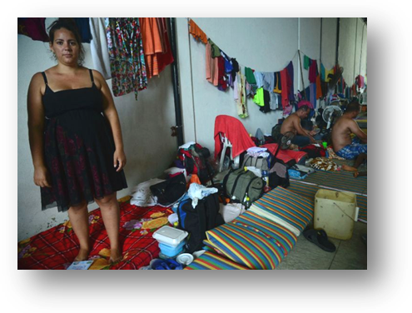

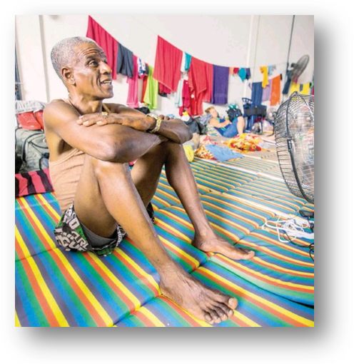
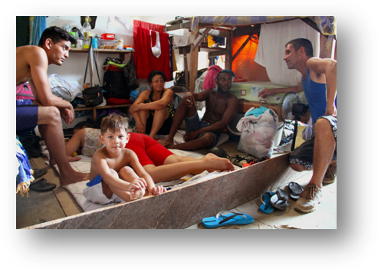
"Brother, there are corpses in the jungle. Don’t get frightened when you come across some”, Alejandro Labarte, a 32-year-old Cuban, listens to a recorded message. The warning was sent by one of the first Cubans who dared to venture into the “Darién Gap” nine days earlier. "We don’t want that, but if it is the only way to escape, we prefer to die there than to go back to Cuba," says Alejandro, who uses his phone as a safe. It stores the confessions of those who have already reached Panama; the films in which the officers of the Migración Colombia (Migration Authority of the Ministry of Foreign Affairs) forcefully remove his compatriots from the Turbo, pictures of the helicopter hovering low over the camp where they slept. "People are scared. The helicopter that circles ominously around all day fills people with fear. Pregnant women are the most affected among us”, he adds. Three days ago one of them miscarried.

Forty-one-year-old Ariel Jaca's has a machete, plastic slippers, biscuits, serum and rope. He is a specialist in social sciences and left Cuba because of the hopeless economic situation. He believes that his equipment will be useful in the travel he started last Saturday and the end of which is nowhere near in sight. "They say that animals do not pose a great danger, but that there is a place that is called La Montaña de la Muerte – The Mountain of Death, extremely difficult to climb. “The rope will come in handy – we’ll be pulling each other up on it.” Ariel travels without any relatives. He became friends with other Cubans and together they are planning to reach Panama and then cross the subsequent borders until they have come to the USA. He is aware the challenges are formidable – recently, Costa Rica and Nicaragua have closed their borders to immigrants.

"If others managed, why shouldn’t we do so?" Says Aily Torres, a 28-year-old. He speaks in plural. She was four months pregnant when she got on one of the boats loaded with migrants. "Of course I'm scared, but I'm not looking back. I couldn’t carry on trying to survive on $10 a month; I need a decent job. " They were resigned in the face of the refusal of the Colombian government to organize a flight to Mexico, with the authorities being reluctant, as the officials put it, to become a link in the chain of people smuggling. Now the Cubans slowly embark on the unfriendly Darién trail despite the fear of what the future may hold.

Source: Thinktrip for US-boundCubansis hard? Do itpregnantw https://www.yahoo.com/news/think-trip-us-bound-cubans-hard-pregnant-054309223.html

Carol Monssem, Central African Republic
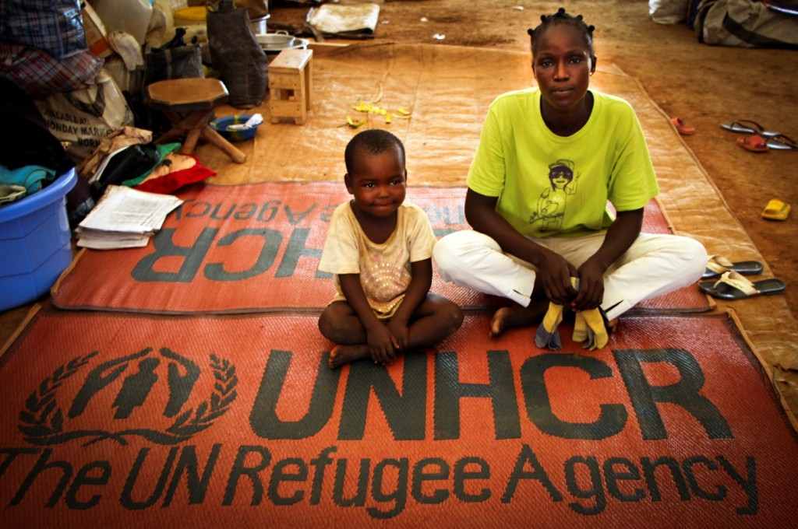

“My village is at the foot of a hill, which gives a beautiful view over the surrounding valley”, says Carol Monss, 29. "The trees are full of fruit, and you can even find gold in the soil. The place, where the minaret stands right next to Christian church towers, had been calm until one winter day, when the piece and quiet were shattered. Suddenly, the streets where children had been playing only the previous day were now full of the dead. It took a week for The Red Cross to collect all the the bodies.

Carol, her husband and their five children were asleep on 4 February 2013 when armed troops from the military formation called Seleka attacked their village, which lies 260 kilometers away from the capital of the Central African Republic, Bangul. The sounds of shooting took them by surprise. They were frightened. The rebels surrounded the village, but Carol and the children had managed to hide in the thickets.

"When I returned five days later, I realized I had lost virtually all my possession”, Carol recalls. "The house was burned to the ground and I didn’t have any money or food. What is more, my husband had been abducted. I went to the rebels and begged them to let him go, but they were deaf to my requests. With the youngest child in my arms and a piece of bread from a neighbor, I went with my family to Bangul. This trip was the saddest moment in my life.”
Carol and her children arrived at Don Bosco, a camp for internally displaced persons. There she is still waiting for more peaceful times, for work and for her husband. "Long-term peace can only be achieved in one way," says Carol. "All parties to the conflict must acknowledge their faults and sincerely apologize."

Source: http://stories.unhcr.org/pl/historia-carol-republiki-rodkowoafrykaskiej-p126.html

Dala, Myanmar (formerly known as Burma)

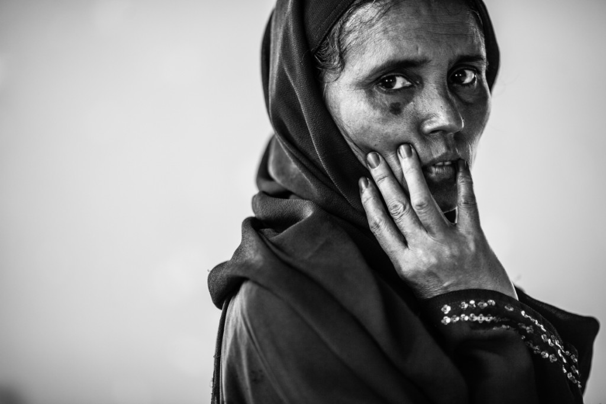
Dala and her husband Mohammed used to live in Burma, where they had a farm, with five cows, three bulls and a herd of goats. The army forced Mohammed into slave labor as a porter. He worked for them without food and water, while the neglected farm was deteriorating. Then, their cows and goats began to disappear, just as other local people began telling them they were not Burmese but vagrants from Bangladesh.
Mohammed does not remember when it was they were supposed to come to Burma because his father, his grandfather and even his grandfather's grandfather lived in the village. They seem to have been there forever.
They decided to flee abroad. For three days they hacked through the jungle and when the Bangladeshi border guards spotted them, the family were in such a state that the guards did not have the heart to stop their progress. It was 21 years ago.
When Dala's daughter was 23, she was raped in the refugee camp they were living in. The tragedy became her pass to the West and her daughter was resettled to Canada. It was five years ago. The daughter calls her mum regularly, but has little good news for her. So far, she has been unable to find a job. Another Muslim family took her in, but they struggled themselves and eventually had to give her away.
Dala is worried about her daughter, but believes that as soon as they are reunited in Canada, everything will work out. However, it is difficult for them to go to the West. They have five children, and half of their life they have spent in the refugee camp in Kutupalong.
Dala and Mohammed occasionally dream that there is no cruel army in Burma or bad neighbors who are aggravated by their religion. In the dream, they live in their village, look after the farm, and there is no refugee camp in Bangladesh – their daughter does not live in remote Canada, but with them.
Source: http://stories.unhcr.org/pl/bangladesz-historia-dali-p18.html

Doaa Al Zamel i Bassem, Syria

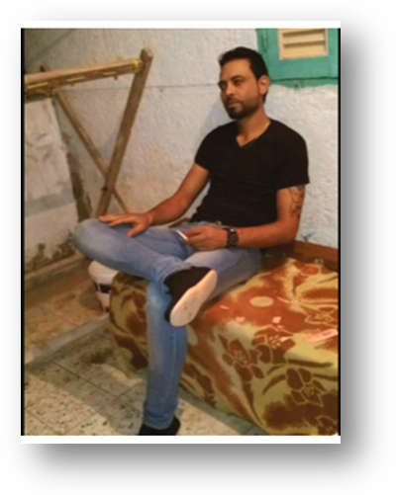
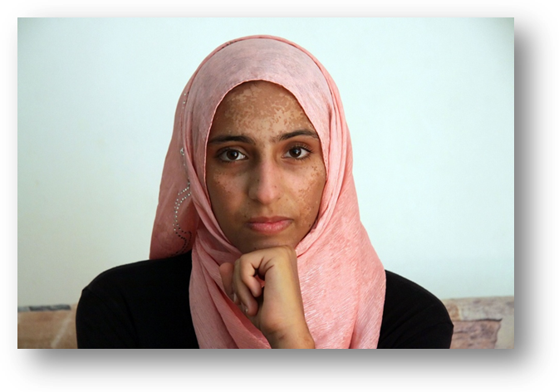

Doaa, 19 year old Syrian was living in Egypt. She had to survive from day to day, earning per diems with no contract. She moved to Egypt with her family after her father’s company had been blown apart by a bomb. She didn’t feel safe in Egypt because of an incident when strangers tried to kidnap her. That’s when her fiancée Bassem came up with the idea to go to Europe in search of a safe place, a job for him and studies for her. Doaa agreed reluctantly because she couldn’t swim and was always scared of water. Apart from that, she knew how cruel the smugglers can be and that 2000 people drowned in the Mediterranean sea, that year only.
Bassem spent all his lifetime savings on a trip from Egypt to Europe. On Saturday morning they got the message that a ship is waiting for them on the beach. It was an old fishing boat with 500 people on board already – 300 on the low deck and 200 on the top. 100 children among them. They sailed for three days – crowded, with no food, no water, not sure what tomorrow will bring. On the fourth day they noticed a smaller boat that was supposed to take them on. When they refused, some men started to drill a hole in their boat to force the passengers to transfer. Doaa didn’t want to leave the sinking boat but Bassem found her a life ring so she wouldn’t drown. Dead bodies started to float around them. Some would take off their life vests choosing to die. The second day in the water Bassem lost all his strength and drowned.
A woman with an 18 month old daughter swam towards Doaa asking her to help her child. Other people started to hand over their children to Doaa – at one point she had three of them. On the fourth day the airplanes came and rescued 11 out of 500 people, including Doaa and Masa – the 18 month old girl. Doaa as one of the few survivors would answer questions posed by the families of other passengers. Academy of Athens, one of the most prestigious Greek institutions, recognized her with the award of bravery. Doaa wants to move to Sweden where her family is living. She dreams of becoming a lawyer of a politician – so that she will be able to help in a fight against world’s inequalities.

Source: The death boats: A survivor’s tale w http://tracks.unhcr.org/2015/06/the-death-boats-a-survivors-tale/

Elsa Peña, Colombia
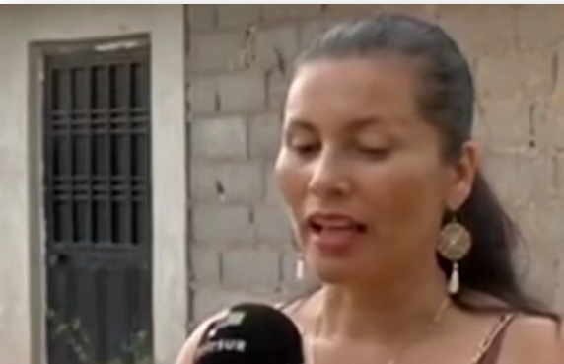

Rosalba Peña and her children fled from Colombia to Venezuela in search for a better life. “We are expatriates from our own country, we are escaping from a wave of murders, protecting our life as well as the life of our children.”

Rosabela highlights that since she’s lived in Venezuela, she’s using the blessings offered by the government of the country, such as free access to medical care and medication, as well as the access to food through the Mercal network.
“I feel respected; old people and children are well-respected here. Our life has improved. Our stay here has slightly reduced the trauma caused by the Colombian violence” – she highlights.
Elsa’s husband – a left-wing party leader is considered missing in Colombia.
“I ran away from violence to save the lives of my children.”
In Venezuela, she received the necessary help and care, “something that they did not want to give us in our country, as I didn’t exist for the Colombian government. The Colombian internal conflict is brutal. They need to stop with the makeshift solutions, because the people of Colombia have already found what violence, bombings and forced disappearances are at their own cost.”

Source: Venezuela y Colombia: Historias de la fronterawhttp://www.telesurtv.net/telesuragenda/Venezuela-y-Colombia-Historias-de-la-frontera-20150828-0311.html
Gonzalo Alejandro Gonzales, Guatemala
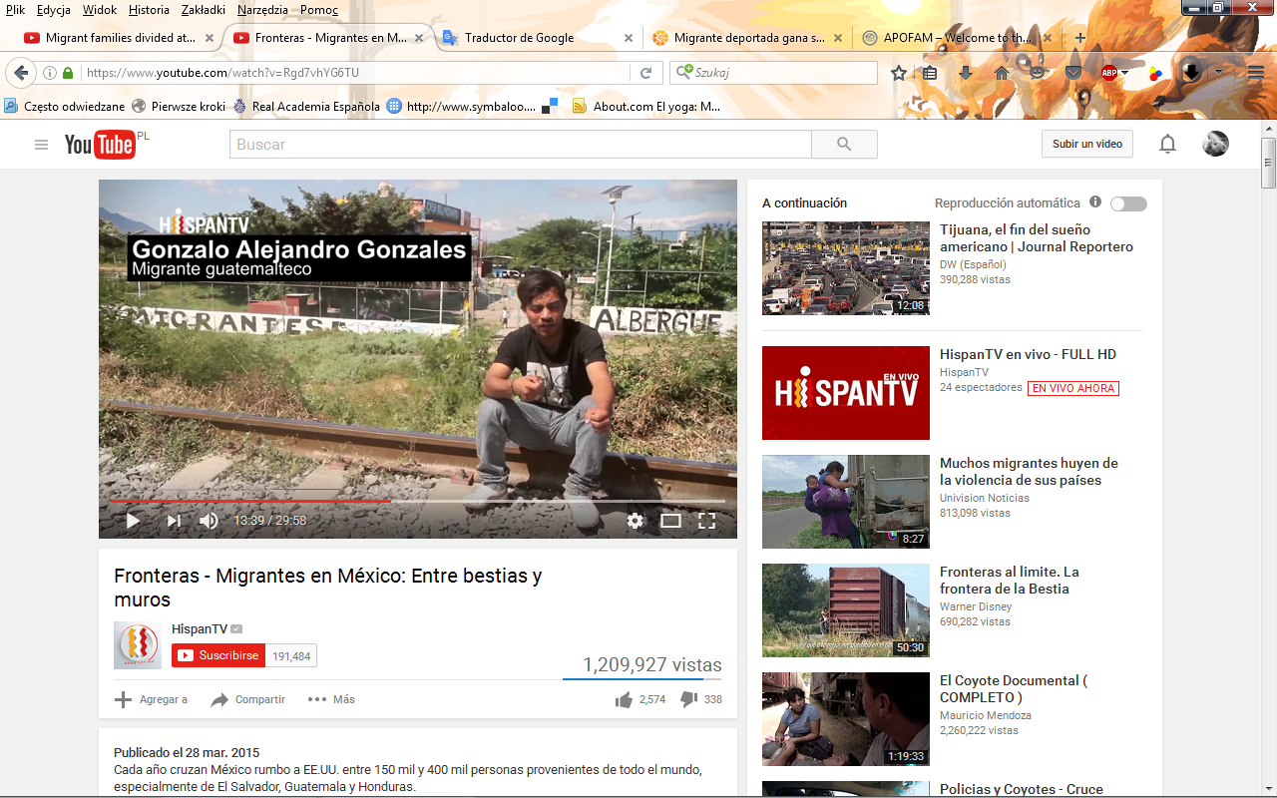

Gonzalo Alejandro Gonzales travelled to USA through Mexico – just like 120.000 other Guatemalans do yearly. It’s one of the most dangerous illegal border crossings. There is police on one side and gangs along with drug traffickers on the other. The gangs threaten children at the border forcing their parents to let go of their money and valuables. They threatened Gonzalo as well. They hit him on the head – the blood was washing over his back and legs. Then they stabbed him with a machete 26 times. He thought he was going to die.
He managed to hang on for 8 hours while his friend was searching for help. Eventually Gonzalo recovered after being given four blood transfusions. He says that he never felt Mexican but the Mexican blood is running in his veins since that illegal crossing. The hardest thing about migration was having to say goodbye to his brother on the phone.

Source: Fronteras - Migrantes en México: Entre bestias y muros w https://www.youtube.com/watch?v=Rgd7vhYG6TU

Luis Rodriguez i Daysi Alfaro, El Salvador

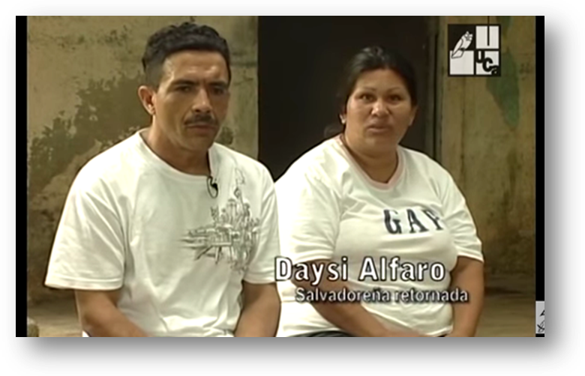

Luis and Daysi were deported from the United States in January 2009 because of their unregulated immigration status. Their children are now under the supervision of the US government. Daysi believes that illegal life in the United States is very difficult. The first few questions that she would typically hear from the potential employer were always about education – whether she had finished high school, had a degree, or completed other courses. Without these, one cannot get a job. At the same time, illegal immigrants have no access to education. Daysi finished only 4 classes of primary school and went to an adult school in the US, where she learned some English. In Los Angeles she worked as a cleaner or nanny, while Luis was employed in construction, either as a plumber or "handyman".

Even for a job in a supermarket, diplomas and documents are essential. Thus the only way to earn money is to sell goods in street markets. Now Luis does not expect much from life. She would only like to get a chance to live with her daughters in El Salvador or in the United States.

Source: El Salvador país de migrantes (2010) w https://www.youtube.com/watch?v=7CfDMXae6Vk

Mahmoud, Senegal
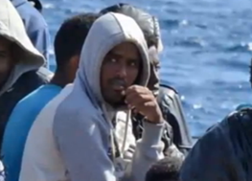

After leaving Senegal, Mahmoud trekked through the scorching Sahara for about twelve days, traveling through Burkina Faso, Mali and Nigeria. The migrants with whom he travelled were transferred from one group of smugglers to another, each of which required payment. No one had food or water, and many had died in the desert. When they finally reached Tripoli, they faced a frightening city exhausted by military battles. When Mahmoud tried to find a job to collect money for another trip, the police arrested him and imprisoned for "a month and four days."

The Catholic bishop of Libya, Father Giovanni Innocenzo Martinelli, pleaded without the people of Africa not to risk their lives crossing the Mediterranean. His requests fell on deaf ears. Hundreds more immigrants are still coming to Libya in search of smugglers who can take them to Europe.

Mahmoud never considered going back. The return journey through the Sahara is as dangerous as the sea route.

One late night, smugglers took Mahmoud and other migrants to a ship. But soon after they set off, the vessel broke down and the group had to turn back. The police fired at them when they were trying to get back to shore, killing seven people. A few days later, the smugglers tried again. They took hundreds of people onto another ship at midnight and managed to send them across the Mediterranean.

Although his horrible journey is over, Mahmoud says that this experience will always remain in his memory, exerting influence on his entire future life. Asked what he advises his Senegalese friends who think of a similar crossing, he replies, "Never, ever, do what I've done."

Source: One Migrant’s Harrowing Journey From Senegal to Italy w http://time.com/3829078/mediterranean-migrant-boat-senegal-story/

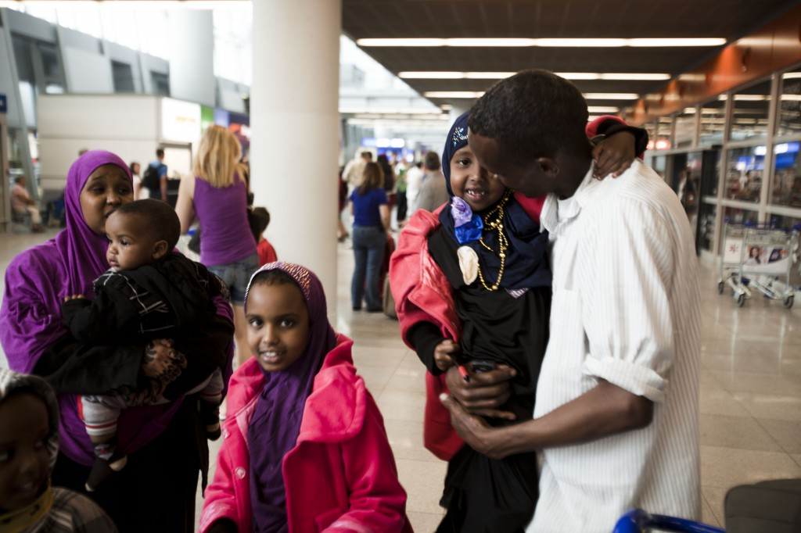
Mohad, Somalia

In January of 2013, Mohad came from Malta to Poland, where he obtained the refugee status. Warsaw was covered with snow at the time and the temperature was a negative 15 degrees. It was 30 degrees hotter in Valletta.
Mohad had only one reason for replacing Malta with Poland. A very important reason. Admittedly, he had a stable job in Malta, but so what, if he couldn’t be there with his family.
In 2008 Mohad, a fisherman from Kismayo in Somalia, had to leave his home due to threats from the Islamist group. It had to be a lonely escape. His children were too young to survive the hardships of travelling into the unknown and his wife was pregnant. “I’m going to find safe shelter and I’m going to get you to me, you will see. Sooner or later,” he said to her as he quickly said goodbye.
He made his promise come true significantly “later” than “sooner”. In his search for safe shelter, he crossed the Sahara Desert and got to the Mediterranean Sea, where, together with tens of other refugees, he set off to Europe on a boat that was falling apart. “They gave us a GPS and told us to head towards Malta,” said Mohad, looking back. “We arrived there after four days. One more day and I would have died of thirst.”
Admittedly, Mohad was safe in Malta, but he missed his family who have found shelter in Kenya for the meantime. When it turned out that the government of Malta does not allow family reunification, he began looking for other options. Five long years passed this way. One day, he received an offer to move to Poland. “I only asked them if I would be able to bring my family,” he told me.
His determination finally paid off. Thanks to the support from the UNHCR, the Polish government and a couple of non-governmental organisations, he could finally welcome his wife and children at the airport in Warsaw. The relief on his face was almost tangible when he realised that he just fulfilled his promise.
Source: http://stories.unhcr.org/pl/mohad-najbardziej-tskni-za-rodzin-p34.html

