ANEXO 4
Ejemplo para el ejercicio "¿Qué mensaje escuchas?"
(Letras y palabras de la canción 'nubes)

Este es un ejemplo para el ejercicio "¿Qué mensaje escuchas?". Puedes elegir las letras de cualquier canción. Hay varios sitios web con letras de canciones. En el siguiente ejemplo elegimos http://www.azlyrics.com. En la parte superior derecha de la página, en la búsqueda del motor escribe el nombre de la canción o del cantante,
Ejemplo 1
Canción "Believer" - Imagine Dragons
First things first
I'ma say all the words inside my head
I'm fired up and tired of the way that things have been, oh ooh
The way that things have been, oh ooh
Second thing
Second, don't you tell me what you think that I can be
I'm the one at the sail, I'm the master of my sea, oh ooh
The master of my sea, oh ooh
I was broken from a young age
Taking my soul into the masses
Write down my poems for the few
That looked at me took to me, shook to me, feeling me
Singing from heart ache from the pain
Take up my message from the veins
Speaking my lesson from the brain
Seeing the beauty through the
(Pain)
You made me a, you made me a believer, believer
(Pain, pain)
You break me down, you build me up, believer, believer
(Pain)
I let the bullets fly, oh let them rain
My luck, my love, my God, they came from
(Pain)
You made me a, you made me a believer, believer
Third things third
Send a prayer to the ones up above
All the hate that you've heard has turned your spirit to a dove, oh ooh
Your spirit up above, oh ooh
I was choking in the crowd
Living my brain up in the cloud
Falling like ashes to the ground
Hoping my feelings, they would drown
But they never did, ever lived, ebbing and flowing
Inhibited, limited
Till it broke up and it rained down
It rained down, like
(Pain)
You made me a, you made me a believer, believer
(Pain, pain)
You break me down, you built me up, believer, believer
(Pain)
I let the bullets fly, oh let them rain
My luck, my love, my God, they came from
(Pain)
You made me a, you made me a believer, believer
Last things last
By the grace of the fire and the flames
You're the face of the future, the blood in my veins, oh ooh
The blood in my veins, oh ooh
But they never did, ever lived, ebbing and flowing
Inhibited, limited
Till it broke up and it rained down
It rained down, like
(Pain)
You made me a, you made me a believer, believer
(Pain, pain)
You break me down, you built me up, believer, believer
(Pain)
I let the bullets fly, oh let them rain
My luck, my love, my God, they came from
(Pain)
You made me a, you made me a believer, believer

http://www.azlyrics.com/lyrics/imaginedragons/believer.html
Copiar pegar las letras de las canciones y luego ir a la www.wordclouds.com.
Haga clic en el asistente y pegue las letras.
El resultado de las palabras "nube de esta canción lírica es la imagen de abajo:
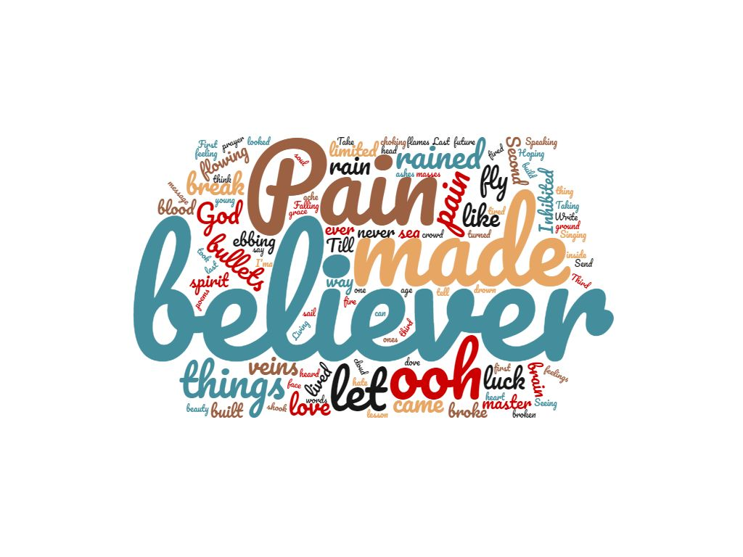
Si todas las palabras no fueron dibujadas, para que las palabras que faltan aparezcan en su nube, o bien reduce la nube de palabras, o baja la frecuencia de estas palabras en la lista de palabras. Es preferible encoger la nube mundial porque es importante mantener la frecuencia de las palabras para el resultado final.
Puede elegir la forma de la nube, los colores, la fuente y si desea una máscara o no.

Ejemplo 2
Canción "Imagine" - John Lennon

Imagine there's no heaven
It's easy if you try
No hell below us
Above us only sky
Imagine all the people
Living for today... Aha-ah...
Imagine there's no countries
It isn't hard to do
Nothing to kill or die for
And no religion, too
Imagine all the people
Living life in peace... You...
You may say I'm a dreamer
But I'm not the only one
I hope someday you'll join us
And the world will be as one
Imagine no possessions
I wonder if you can
No need for greed or hunger
A brotherhood of man
Imagine all the people
Sharing all the world... You...
You may say I'm a dreamer
But I'm not the only one
I hope someday you'll join us
And the world will live as one.

http://www.azlyrics.com/lyrics/johnlennon/imagine.html
Copiar pegar las letras de las canciones y luego ir a la www.wordclouds.com.
Haga clic en el asistente y pegue las letras.
El resultado de las palabras "nube de esta canción lírica es la imagen de abajo:
